
Symbiosis Institute of Technology, Pune
Faculty of Engineering
CSE- Academic Year 2026-27
Java Programming – Lab Batch 2024-28
Lab Assignment No:-14
Name of Student: Sanika Botre
PRN No.: 25070122063
Batch: 2025-29
Class: CSE A-2
Academic Year & Semester: 2026 2nd Semester
Date of Submission:
Title of Assignment: Write a Java program to demonstrate exception handling using try and catch blocks, nested and multiple try-catch blocks.

Learning Objectives: To handle runtime exceptions using try-catch, nested try, and multiple catch blocks.

Theory: Exception handling prevents abnormal termination of programs due to runtime errors. The try block contains code that may generate exceptions, while catch blocks handle specific exceptions. Nested and multiple try-catch structures allow complex error management. Exception handling improves software reliability and user experience by gracefully managing unexpected situations.
Practice questions:
- Create an ATM program handling invalid withdrawal amount using try-catch.
Code: 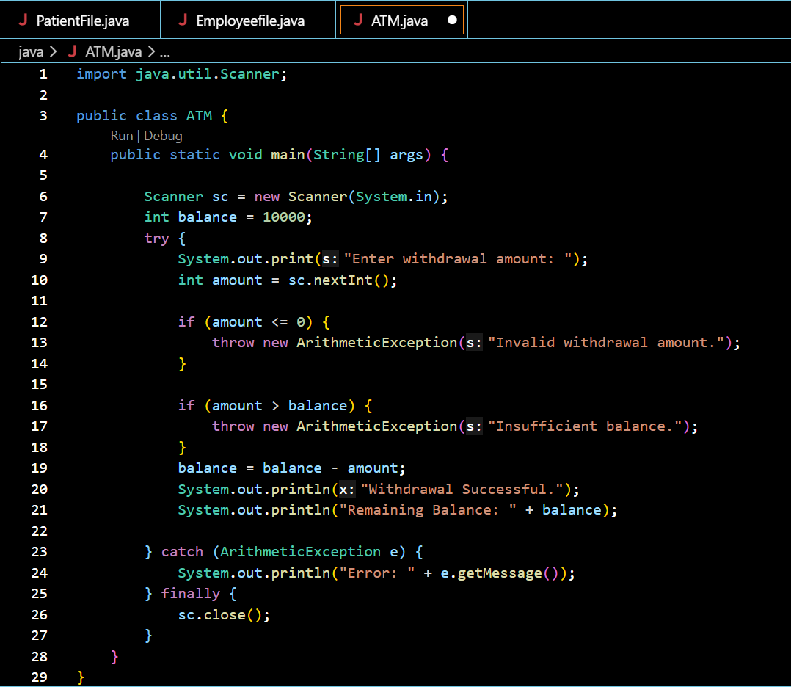

Output Screenshot:
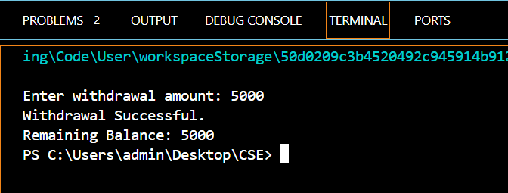

- Create an Online Shopping program that handles an invalid product quantity entered by the user using a try-catch block. Display an appropriate error message if the quantity is less than or equal to zero.
Code:
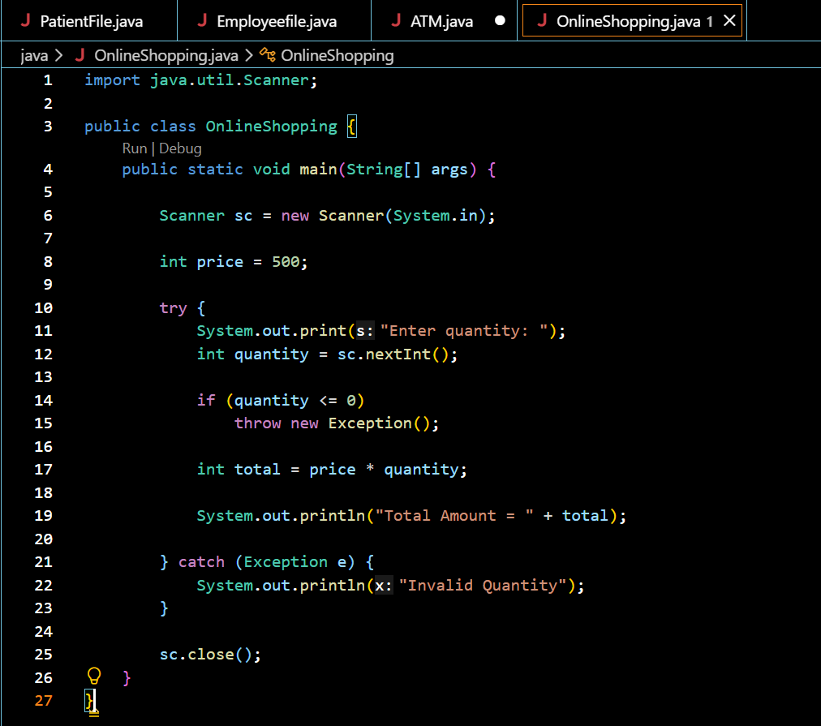
Output Screenshot:
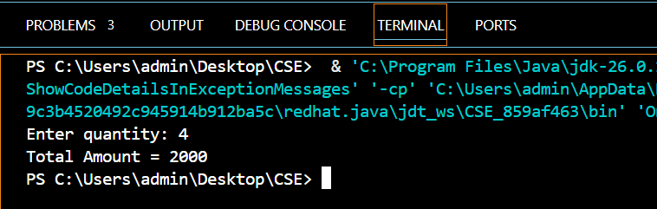
Conclusion:
The program successfully demonstrates exception handling in Java using try and catch blocks. It handles invalid inputs such as incorrect withdrawal amounts and invalid product quantities by displaying appropriate error messages instead of terminating the program abruptly. This improves the reliability, stability, and user-friendliness of the application while ensuring smooth program execution.

